REG-CHM-18 -CMSP Action Log

Step 1 – Log in to the REC Portal as a Change Management team member and click on Change and Release tab and then CMSP Action Log
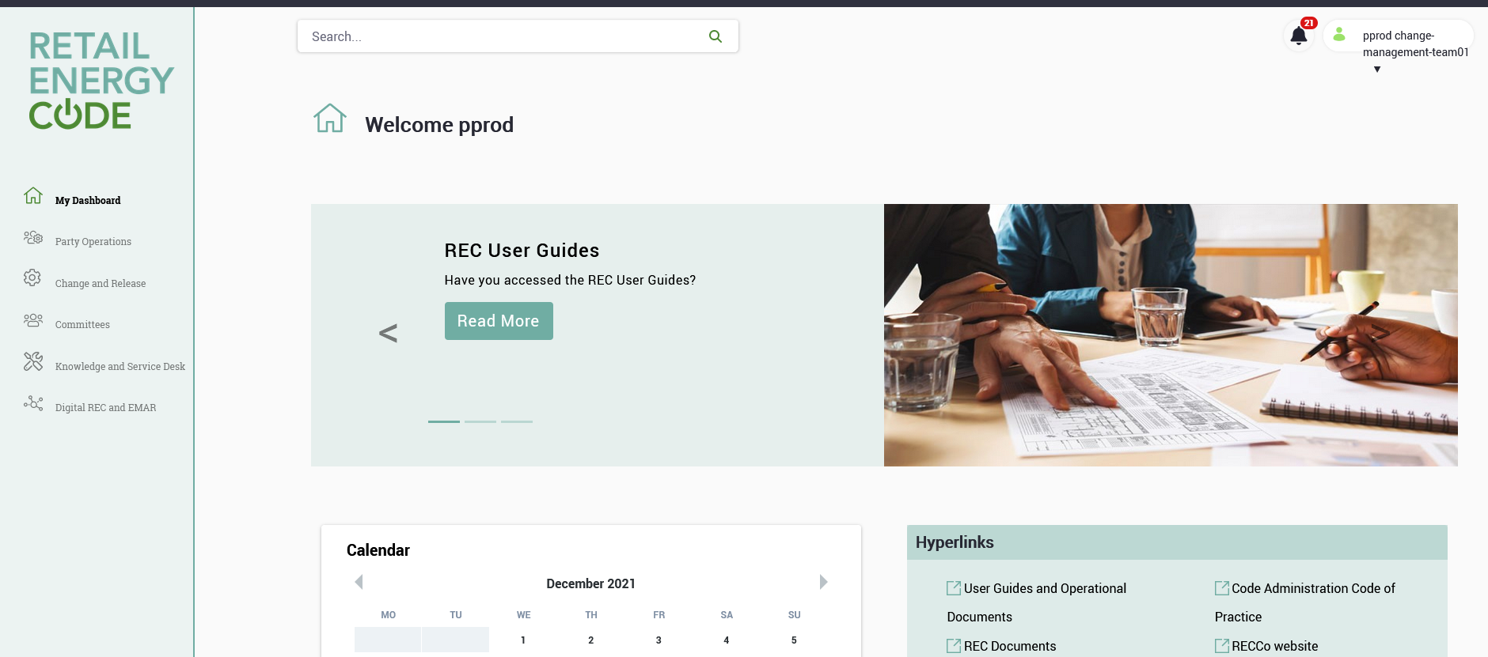
Step 2 – Click on CMSP Action Log
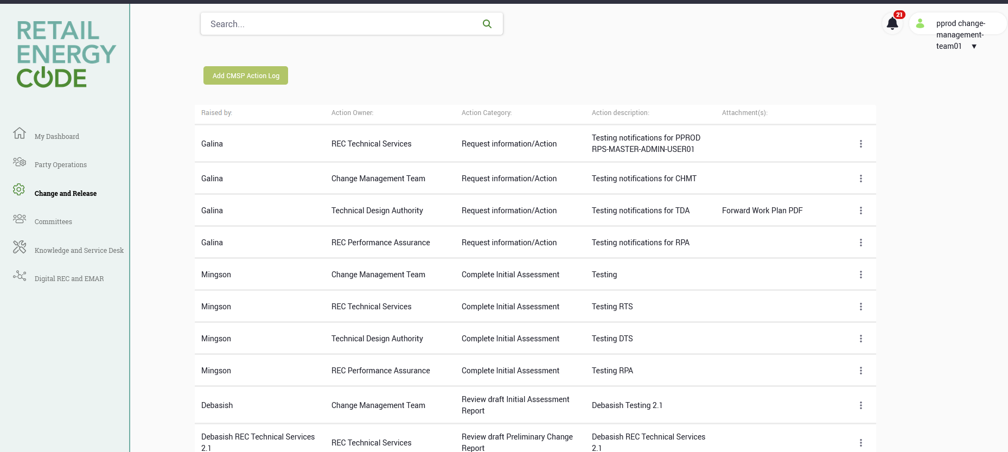
Step 3 - Click on Add CMSP Action log
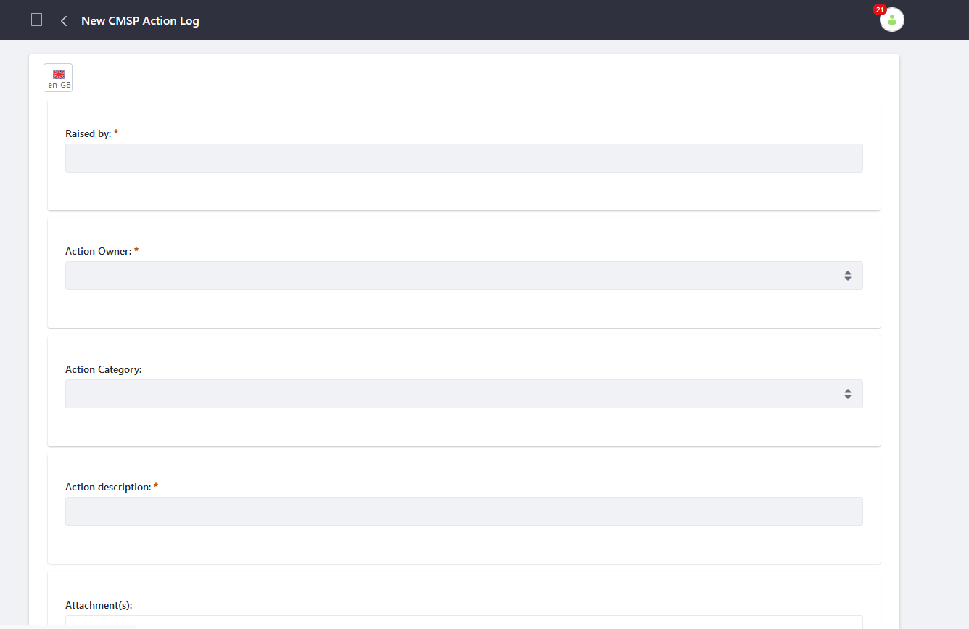
Step 4 - Verify:
Raised by: Manual entry (mandatory field)
Action Owner: Drop down (mandatory field) - this will be role based (e.g. CMT, RPS, RPA etc)
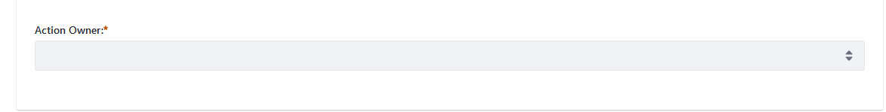
Action Category: Drop down (optional) (e.g. Review IAR, Review PCR, Review Solution Options)
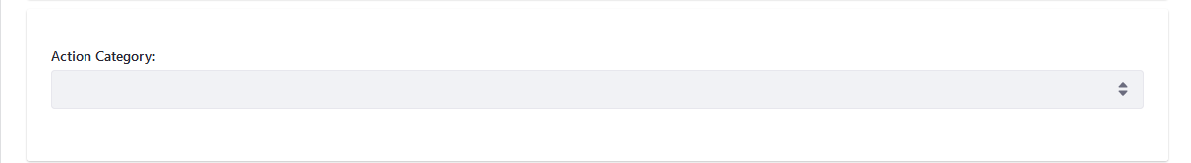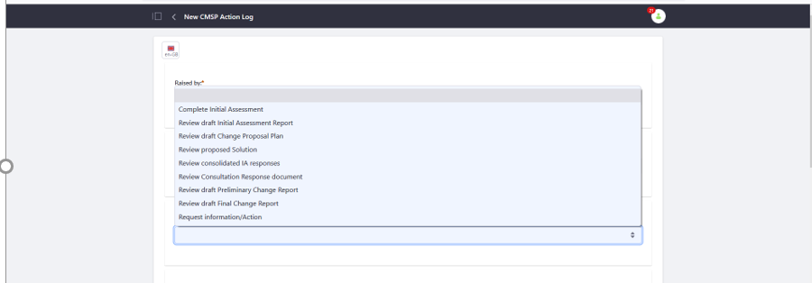
Action description: Free text (mandatory)
Attachment(s): optional – multiple attachments can be added against the record
Link(s): optional – multiple links can be added against the record
Due Date: Manual entry (mandatory),Status: Dropdown (‘Open’ when first raised and then can be set to ‘Closed/completed’),Comments/Notes: Free text (optional) 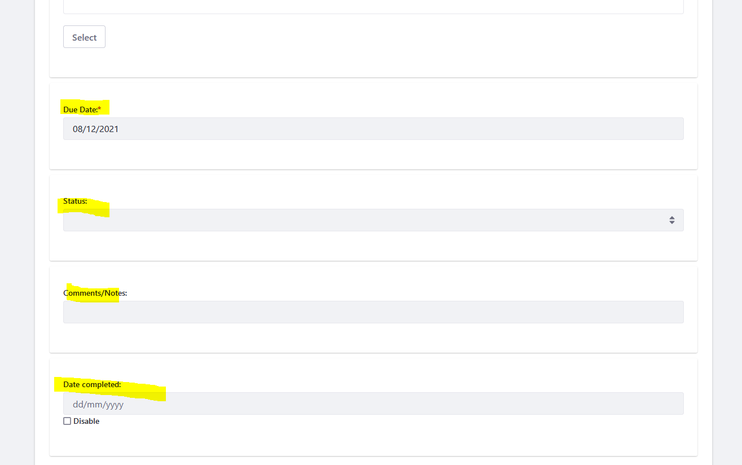

Step 5 - Fill up the Template/Form with all Mandatory fields and if possible all optional fields and click on Submit for Publication. Action Owner: Change Management Team
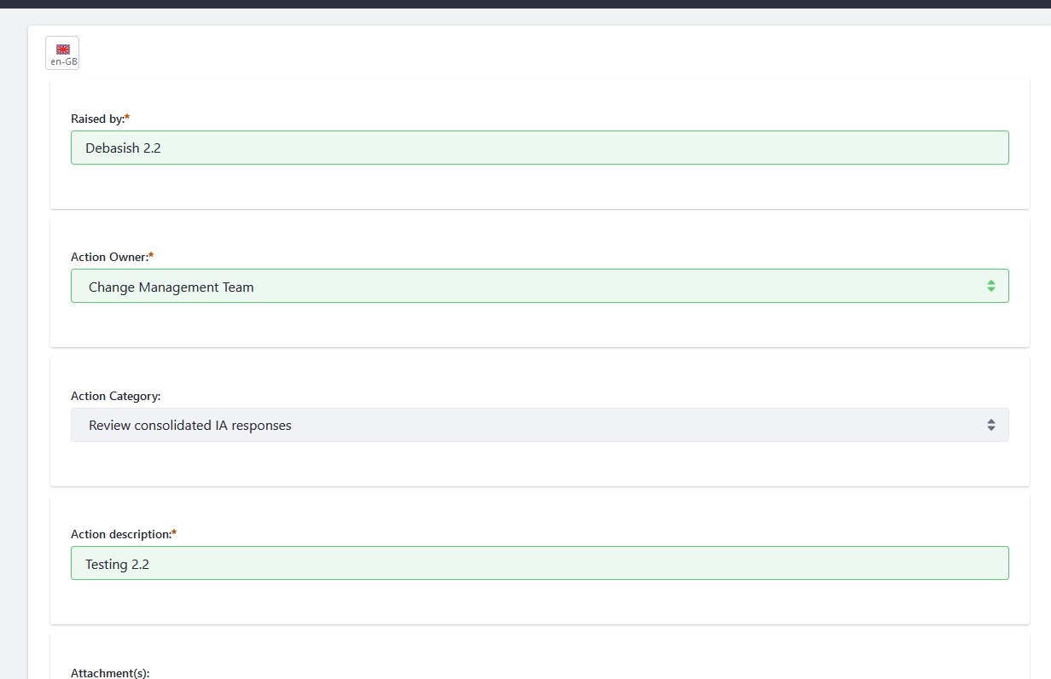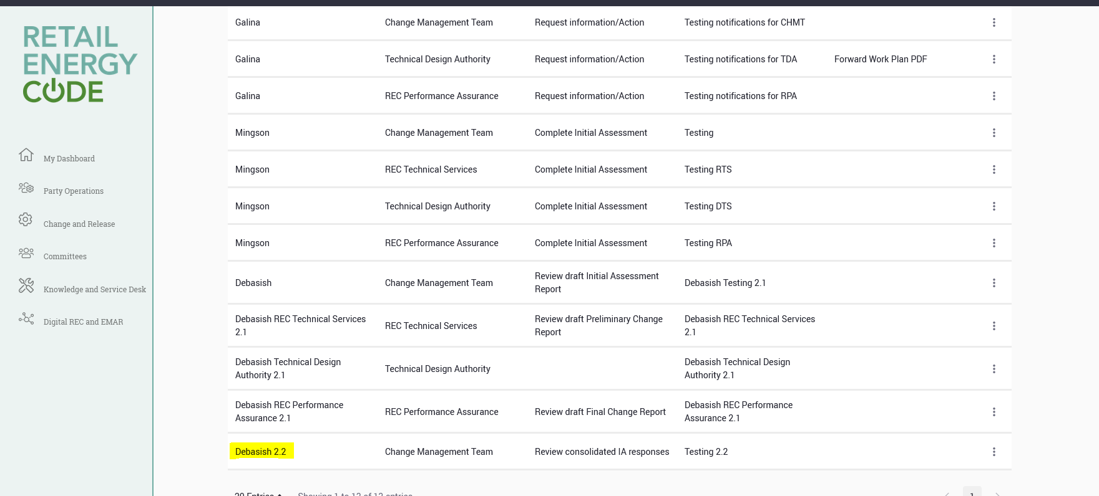
Step 6 - Click on Notification and verify if a notification is received
No notification received (Known Issue- RP-4318)
Step 7 – Navigate back to the CMSP Action Log and click on ‘Add CMSP Action Log’
Step 8 - Fill up the Template/Form with all Mandatory fields and if possible all optional fields and click on Submit for Publication. Action Owner: REC Technical Services 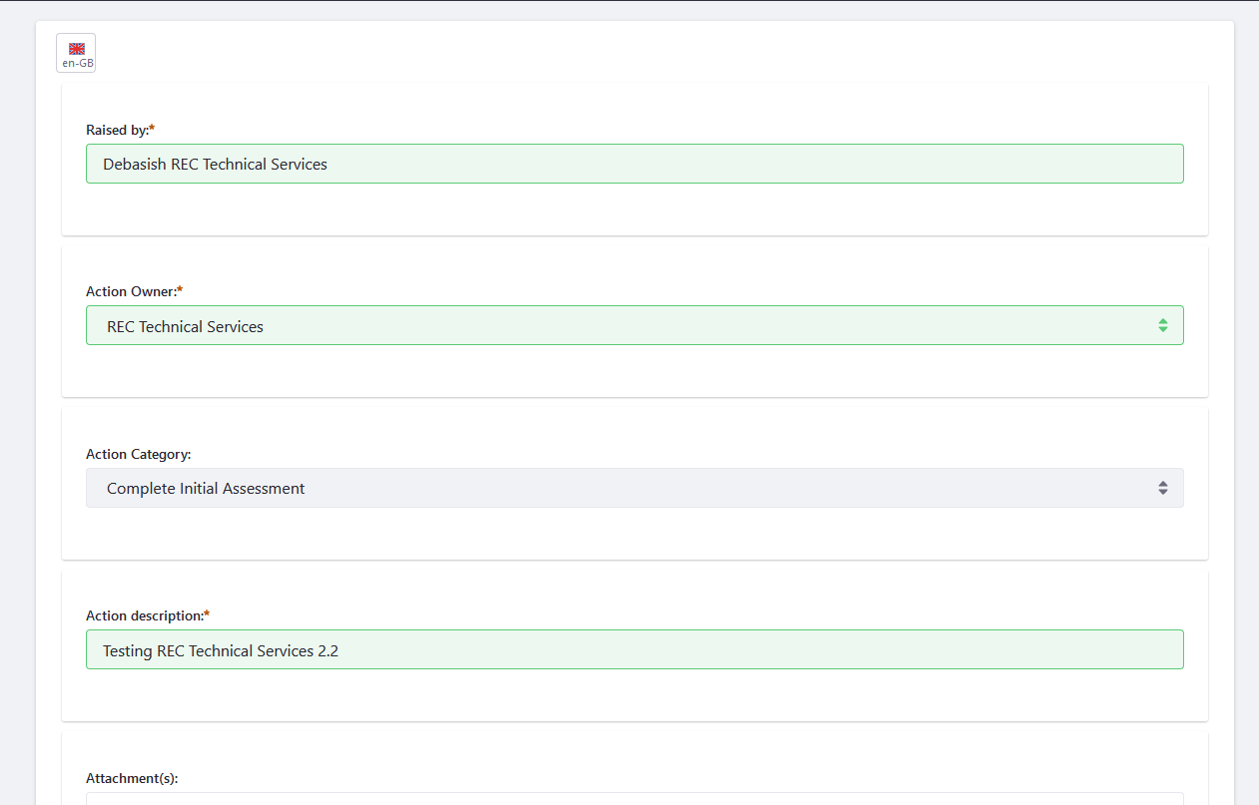 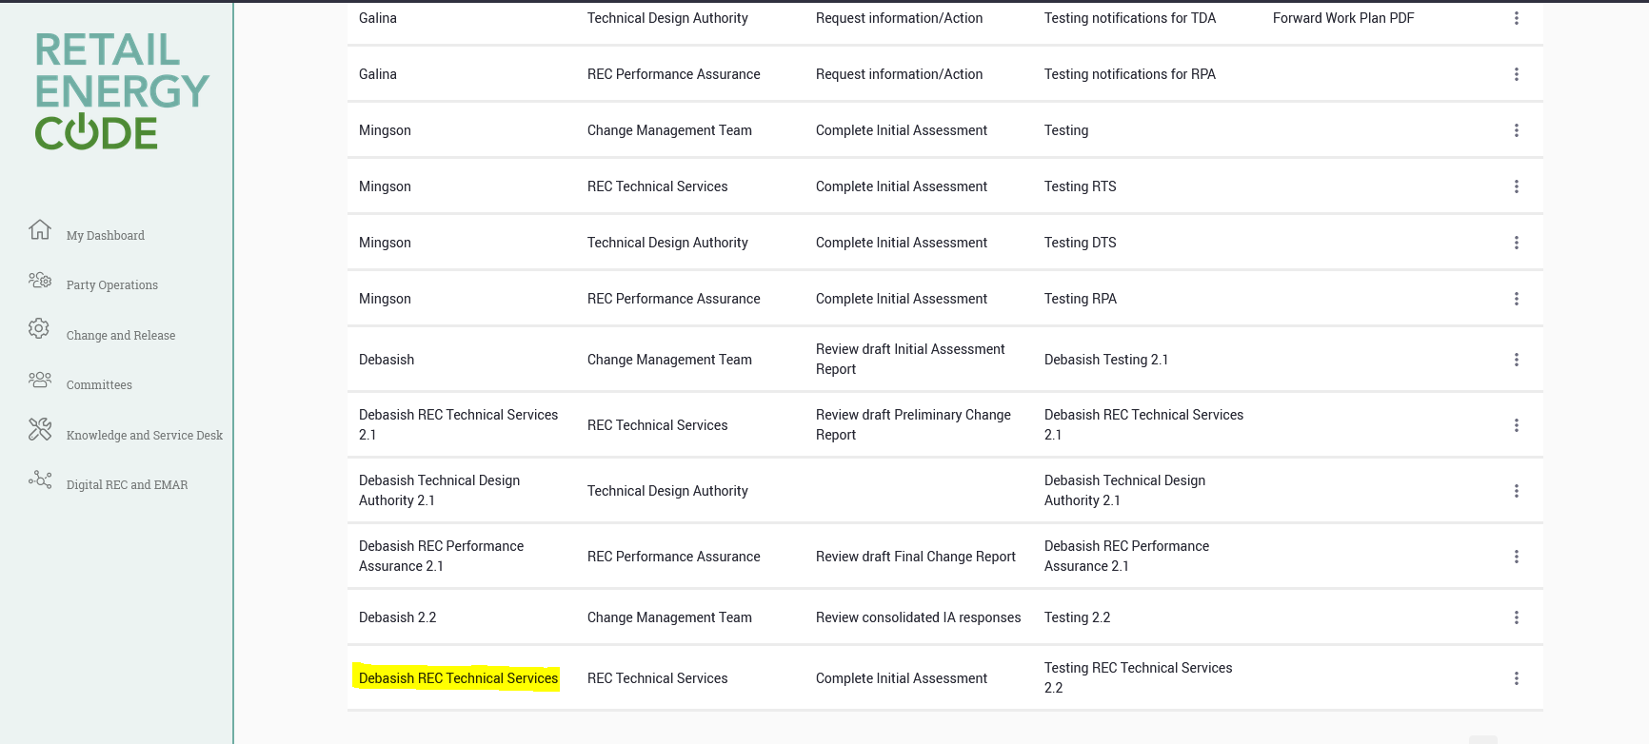

Step 9 - Log on to Portal as a REC Technical Services user and click on Notification and verify if a notification is received
No notification received (Known Issue- RP-4318)
Step 10 – Log in as a Change Management Team member, navigate to CMSP Action Log and click on ‘Add CMSP Action Log’

Step 11 - Fill up the Template/Form with all Mandatory fields and if possible all optional fields and click on Submit for Publication. Action Owner: Technical Design Authority

Step 12 - Log on to Portal as a Technical Design Authority user and click on Notification and verify if a notification is received

No notification received (Known Issue- RP-4318)
Step 13 - Log in as a Change Management Team member, navigate to CMSP Action Log and click on ‘Add CMSP Action Log’

Step 14 - Fill up the Template/Form with all Mandatory fields and if possible all optional fields and click on Submit for Publication. Action Owner: REC Performance Assurance

Step 15 - Log on to Portal as a REC Technical Services user and click on Notification and verify if a notification is received

No notification received (Known Issue- RP-4318)

